THE UNITED REPUBLIC OF TANZANIA
REGIONAL ADMINISTRATION AND LOCAL GOVERNEMENT
FORM FOUR MOCK EXAMINATION- MANYARA.
031/2B PHSICS 2B (actual practical)
TIME: 2:30 HOURS 2025
- This paper consist of two (2) questions. Answer BOTH questions.
- Each question carries twenty –five (25) marks
- Non –programmable calculators may be used.
- The following constants may be useful.
.Acceleration due to gravity g=10mls²
. Pie Л=3.14
- You are provide with a retort stand and its accessories, cotton string of 110cm, a watch, a pendulum bob, cork pads and metre rule
- Set up the apparatus as shown in figure 1 below
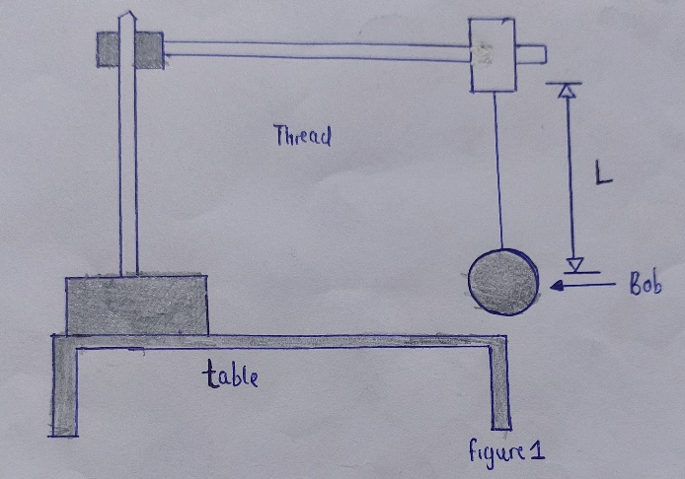
- Set the cotton string/thread at a length of a length l=10cm displace the bob and release it to make oscillation and then determine time “t” taken for complete twenty oscillations (n=20)
- Repeat the procedure in (b) for the volume L=20cm, 30cm, 40cm and 50cm and then.
- Tabulate their results including L(cm) t (sec) and t²(sec²)
- Plot on graph of t²(sec²) a faint length L (cm)
- Find the slope of the graph
- Determine the value of Z, given that
t² =4Л²n²L
Z

- State the significance of Z
- State the aim of this experiment.
- The aim of this experiment is to determine the internal resistance of a cell r and e. m.f E of a dry cell D
- You are provide with a dry cell D, resistance box (R,) an ammeter, voltmeter and key K
- Connect the apparatuses so that you can get readings of ammeter and corresponding readings of voltmeter which was to be connect parallel to the dry cell labelled D.
- Set the resistance box to be I, read and record the ammeter and voltmeter readings.
- Repeat the procedures for resistors R=2,3,4 and 5
- Draw a circuit diagram of connection arrangement.
- Plot the graph of V against I
- Write down the equation represented by the graph in terms of E, r, V and 1
- From your graph find :
- The value of Electromotive force E of a dry cell D
- The internal resistance r of a dry cell:
- The maximum current that cell can deliver to the circuit.

